CAPEX Planning
Datasphere Technical Specification

Contents

1. Document Organization 2
• Document Log 3
• Integration, Related Document Reference 3
2. Object Summary 3
3. Technical Specifications 4
3.1 Data Flow/Replication Flow 4
➢ 3.1.1 Historical Actuals HO and OSS Transaction Data Dataflow: ZSAP_FI_RF_TRANSACTION_DATA_02 4
➢ 3.1.2 APVP Transaction Data Dataflow: L1_FI_MP_DF_APVP_01 4
➢ 3.1.3 APVP EC Transaction Data: L1_APVP_DATA 5
3.2 Data Models 6
• Master Data Models 6
➢ 3.2.1 Division Description Data: 6
• Transaction Data Models 7
➢ 3.2.2 Historical Actuals HO OSS Transaction Data: 7
➢ 3.2.3 APVP Transaction Data: 8
➢ 3.2.4: APVP EC Transaction Data 13
➢ 3.2.5 Tech Crew Transaction Data 16
➢ 3.2.6 Cabin Crew Transaction Data 17
3.3 Technical Details and Mapping 19
3.4 Currency Translation/Unit Conversion 21
3.5 Row level security 21
4. Data Load Frequency 21
5. Unit Test Results 22
6. Glossary 22

Document Organization
This section provides details about this document, previous version(s) of this document and the document(s) referred.

Document Log

Document Version | Status | Date | Name | Role | Comments
1.0 | Initial |  |  | Developer

Integration, Related Document Reference

S. No. | Referred Document Name | Referred Document Version | Referred Document URL (Optional)

Object Summary

OBJECT ID
Short Description | Payroll Planning - Datasphere
Complexity | Low
Business Process Owner
Technical Designer
Developer
Document SharePoint Link

Technical Specifications

3.1 Data Flow/Replication Flow

3.1.1 Historical Actuals HO and OSS Transaction Data Dataflow: ZSAP_FI_RF_TRANSACTION_DATA_02

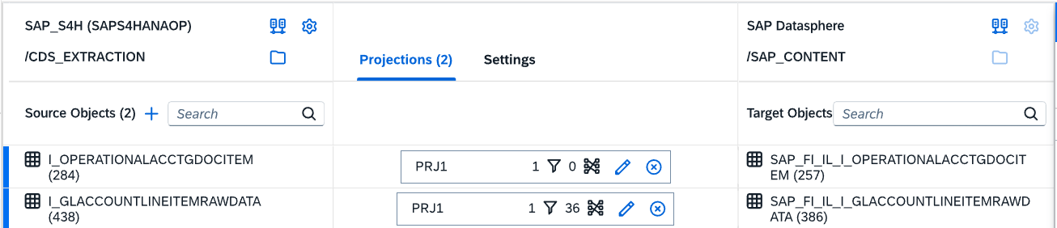

Space Name | SAP_CONTENT
Functional Process Name | Payroll Planning
Data Flow Business & Technical Name | Historical Actuals HO OSS Transaction Data Dataflow: ZSAP_FI_RF_TRANSACTION_DATA_02
Data (Master/Transaction) | Transaction Data
Pseudo Delta Logic (If any) | No
Schedule
Input Parameters | No

Mapping Details:

3.1.2 APVP Transaction Data Dataflow: L1_FI_MP_DF_APVP_01

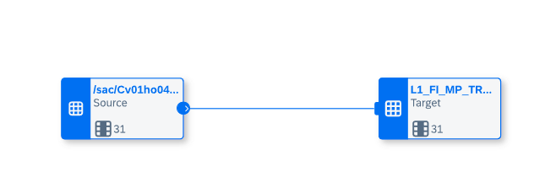

Space Name | L1 SAC Manpower Tenant
Functional Process Name | Payroll Planning
Data Flow Business & Technical Name | APVP Transaction Dataflow:  L1_FI_MP_DF_APVP_01
Data (Master/Transaction) | Transaction
Pseudo Delta Logic (If any) | No
Schedule
Input Parameters | No

Mapping Details:

3.1.3 APVP EC Transaction Data: L1_APVP_DATA

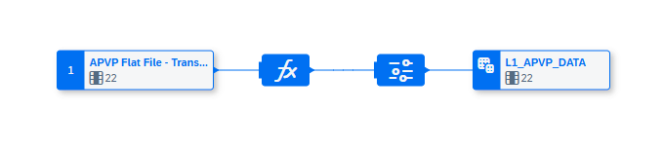

Space Name | Centralized IT
Functional Process Name | Payroll Planning
Data Flow Business & Technical Name | APVP EC Transaction Data:  L1_APVP_DATA
Data (Master/Transaction) | Transaction
Pseudo Delta Logic (If any) | No
Schedule
Input Parameters | No

3.2 Data Models

Master Data Models

3.2.1 Division Description Data:

SQL Relational Dataset View:
Division Description Master View: L2_FI_GL_SR_DIVISION_DES_VIEW_01

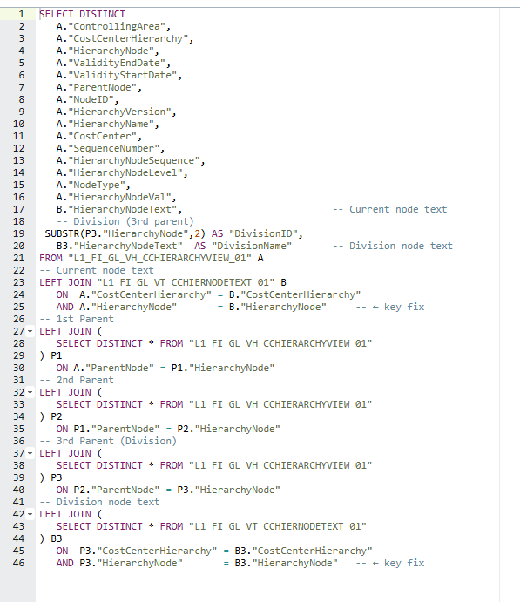

Data Model:
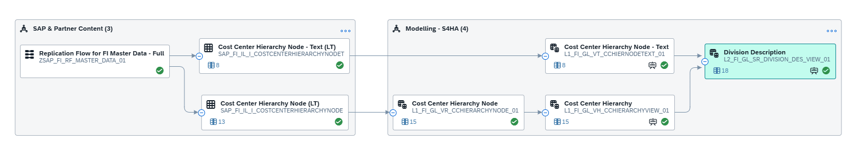

Transaction Data Models

3.2.2 Historical Actuals HO OSS Transaction Data:

Dimension View:
HISTORICAL ACTUALS HO OSS Transaction VIEW: L2_FI_AA_VD_ASSETVIEW_01

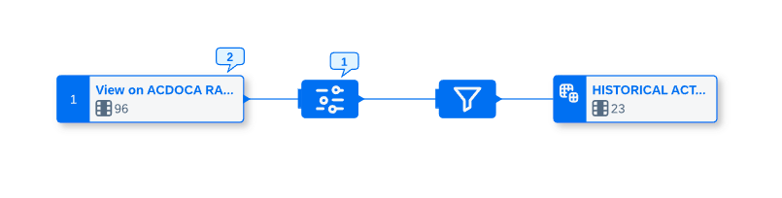

Data Model:

Fact View
HISTORICAL ACTUALS HO OSS VIEW: L3_FI_GL_VF_HISTORICAL_ACTUALS_01
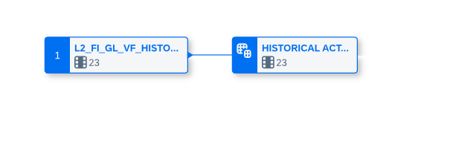

Data Model:

3.2.3 APVP Transaction Data:

- APVP Relational Dataset view: L2_FI_MP_VR_APVP_ASSIGNEDPOS
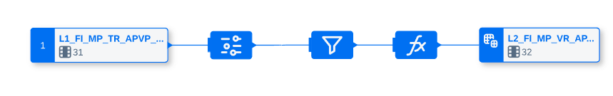
Data Model:
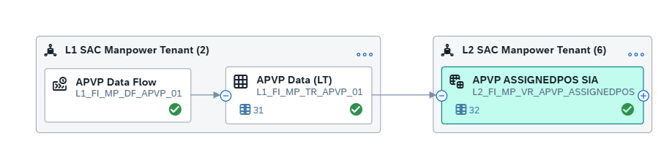
- APVP NUMPOS Relational Dataset View): L2_FI_MP_VR_APVP_NUMPOS

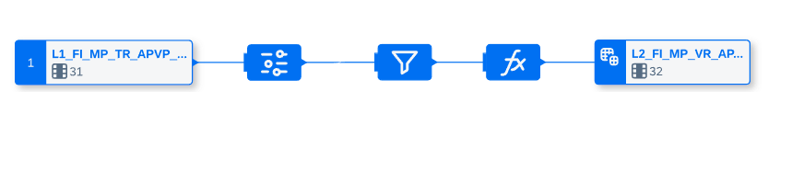
Data Model:

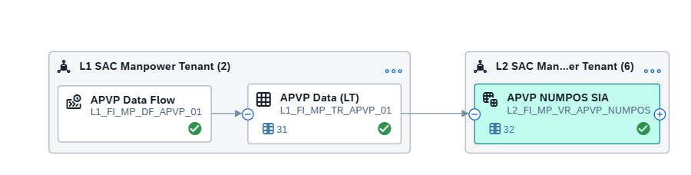

- APVP Additional Relational Dataset View: L2_FI_MP_VR_APVP_ADDITIONAL

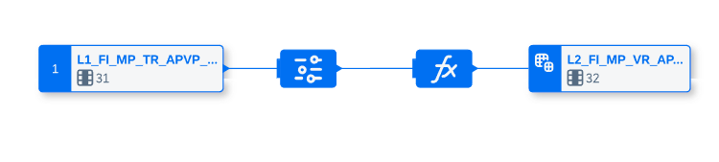
Data Model:
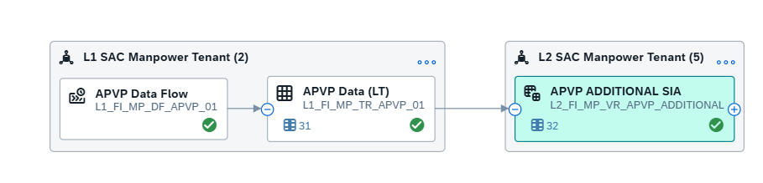
- APVP Vacant Relational Dataset View: L2_FI_MP_VR_APVP_VACANT
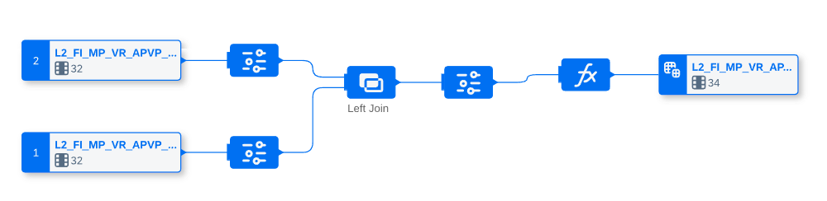
Data Model:
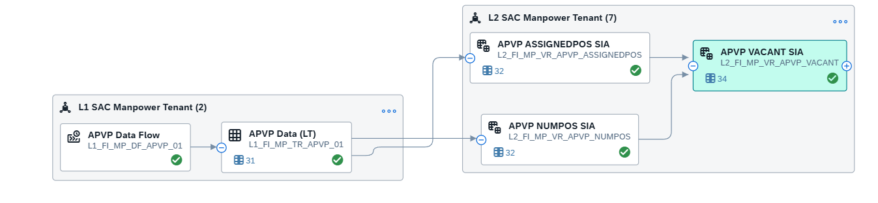
- APVP Addition Vacant combined Relational Dataset: L2_FI_MP_VR_APVP_ADDVACCOMB

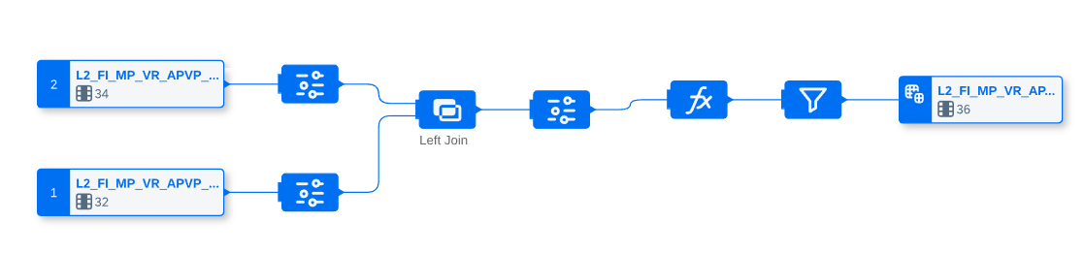
Data Model:
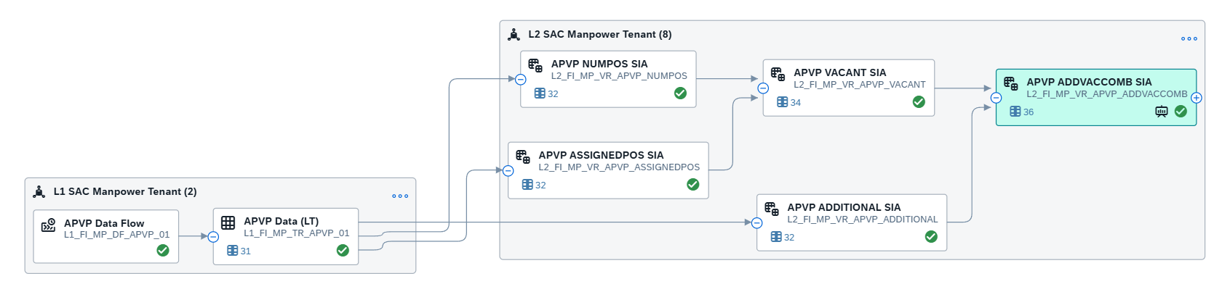
- APVP Exploded SQL Relational Dataset: L2_FI_MP_SR_APVP_EXPLODED

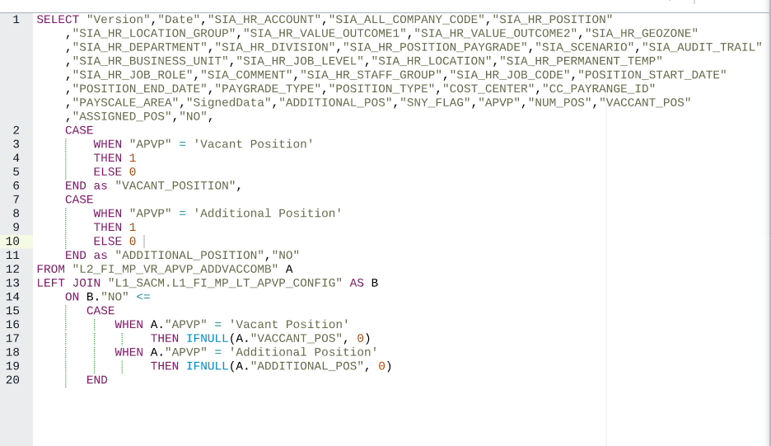
Data Model:

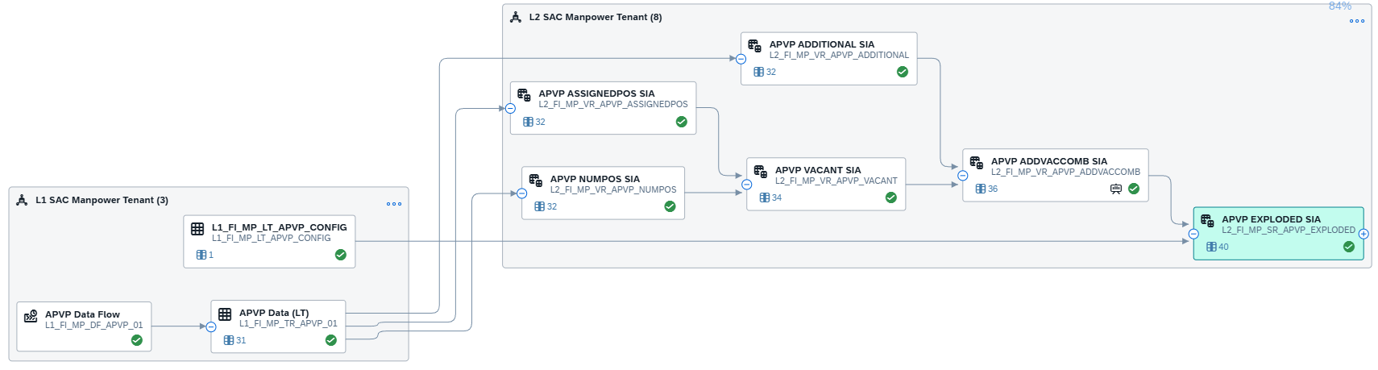

- APVP Final Combined SQL Relational Dataset: L2_FI_MP_SR_APVP_FINALCOMBVIEW

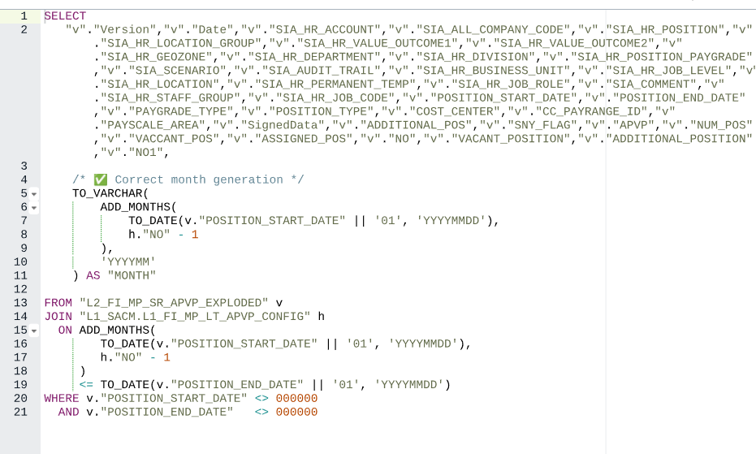

Data Model:

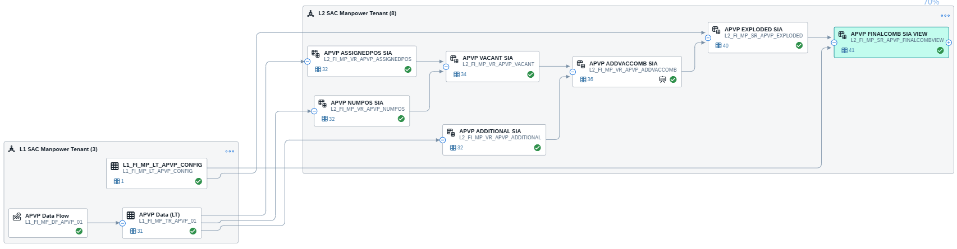

- APVP View (SQL Relational Dataset): L2_FI_MP_SR_APVP_COMBVIEW_01
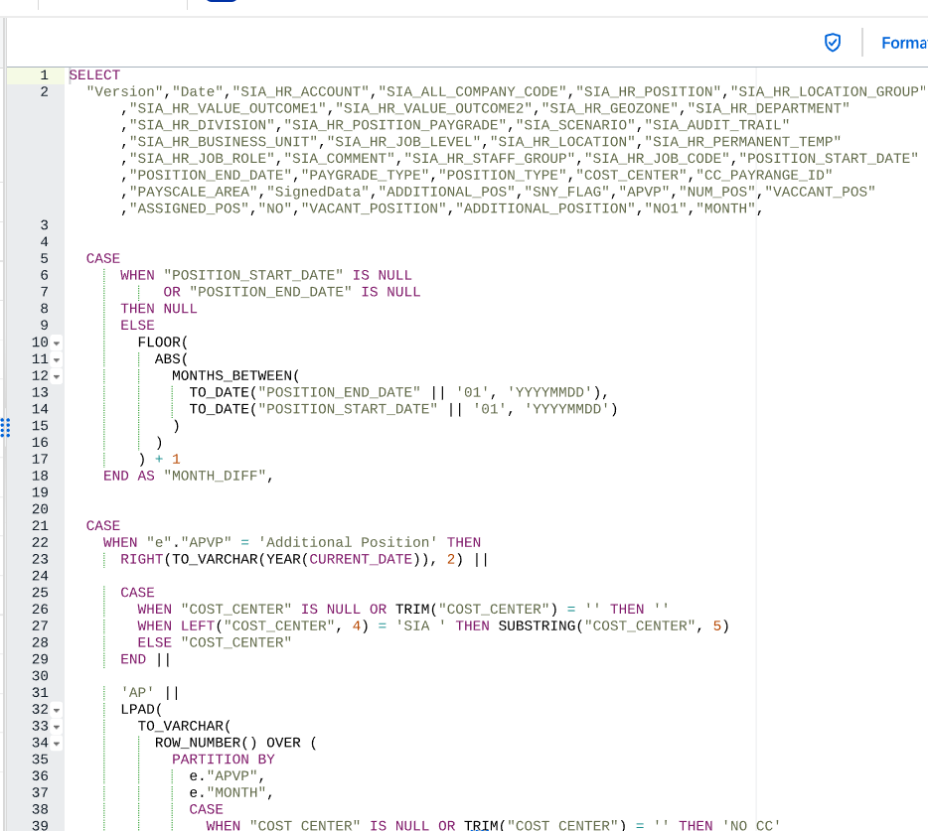
Data Model:

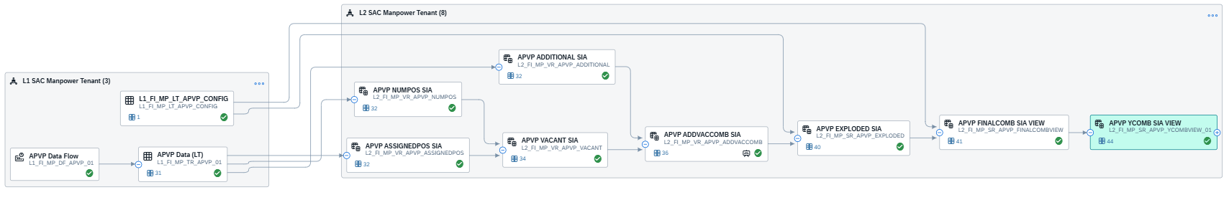

Fact View: APVP - L3_FI_MP_VF_APVP_COMBVIEWCONSUMPTION__01

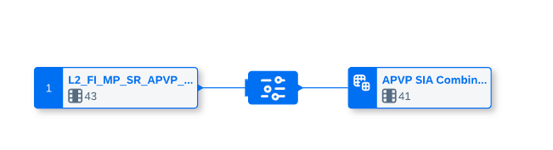
Data Model:

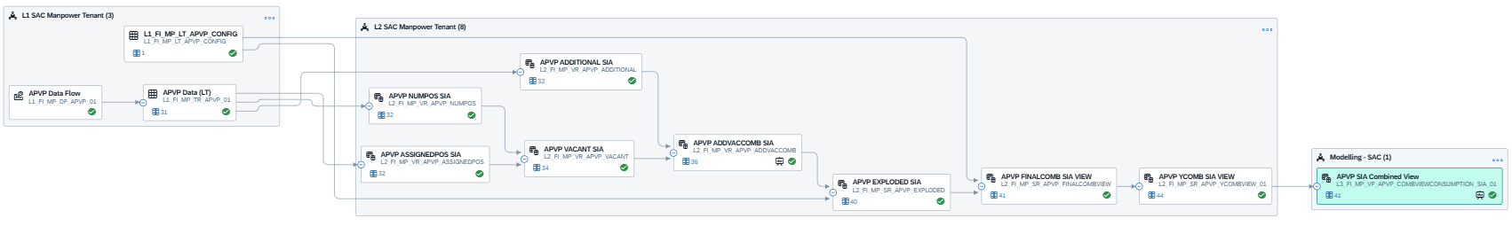

3.2.4: APVP EC Transaction Data
Relational Dataset: APVP SQL Relational view L2_FI_MP_SR_APVP_EXPLODED_E
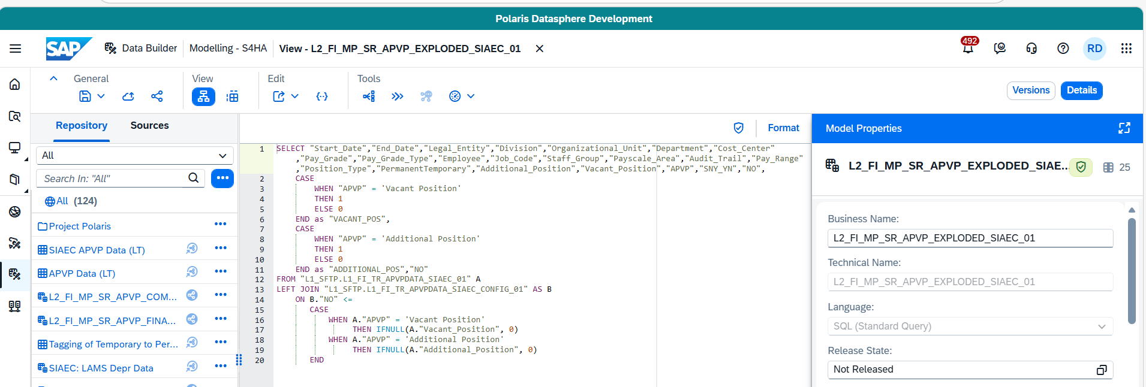
Data Model:
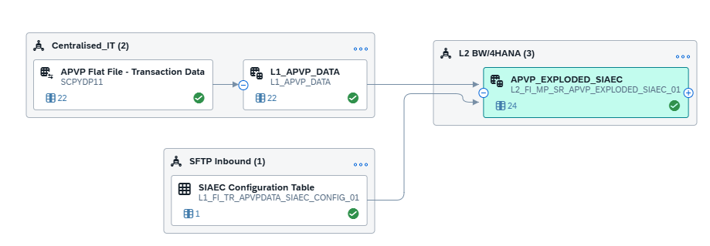
2) APVP EC View (SQL Relational View): L2_FI_MP_SR_APVP_FINALCOMBVIEW_EC_01
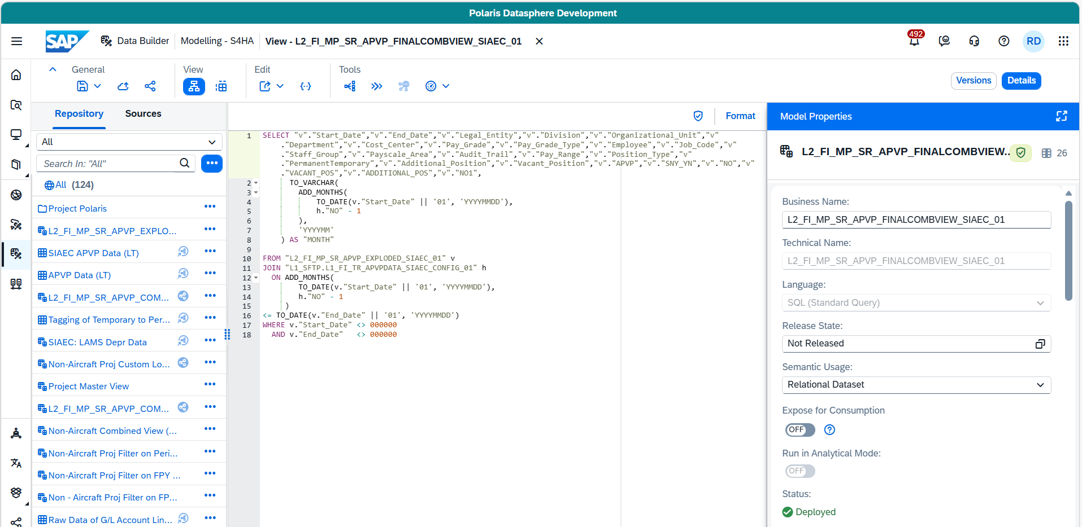
Data Model:
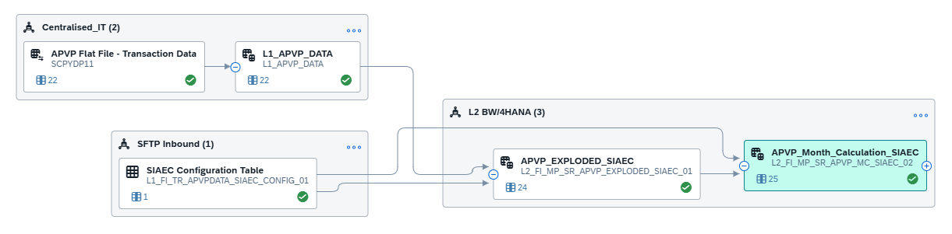
3) APVP EC View (SQL Relational Dataset): L2_FI_MP_SR_APVP_COMBVIEWCONSUMPTION_EC_01
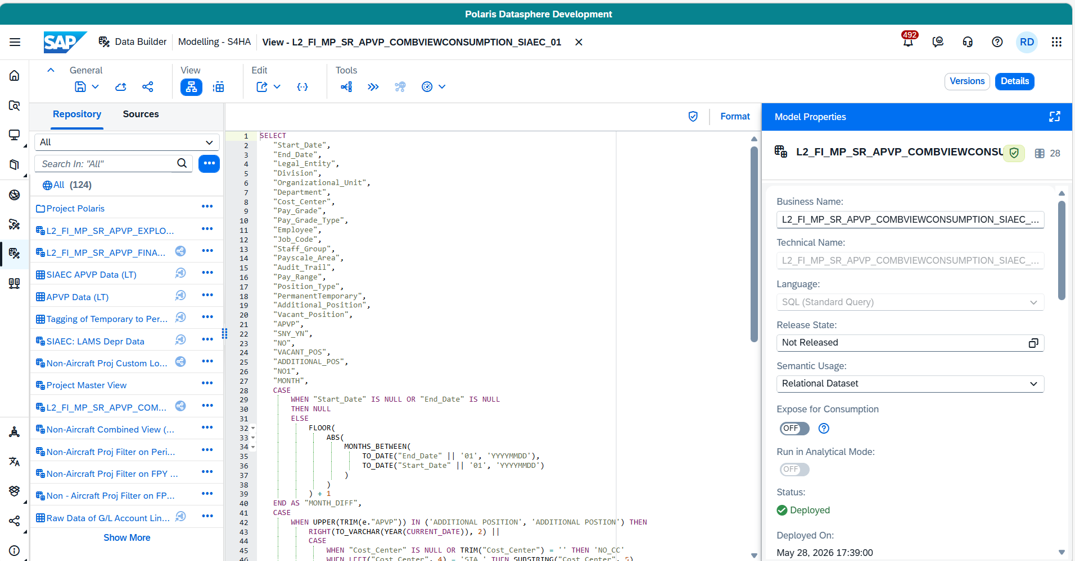

Data Model:

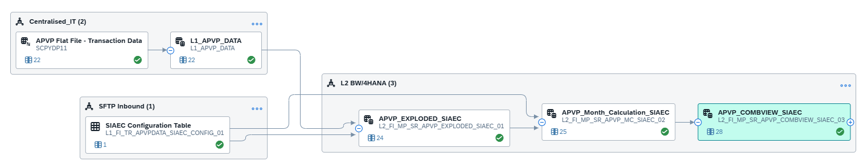

Fact View: APVP EC - L3_FI_MP_VF_APVP_COMBVIEW_EC_01

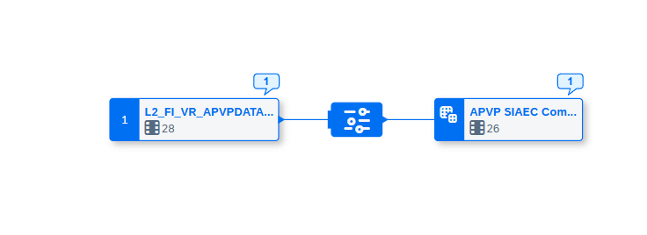

Data Model:
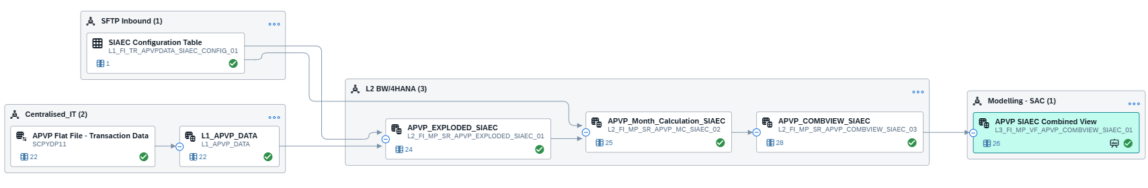

3.2.5 Tech Crew Transaction Data

Fact View:
Tech Crew View - L2_FI_VF_TECH_CREW_VIEW_01

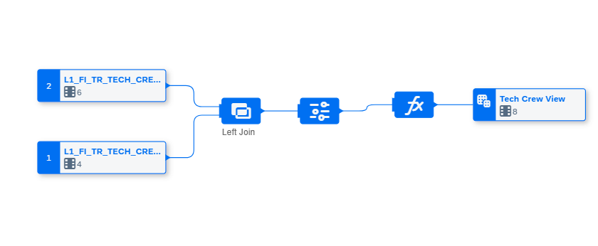

Data Model:
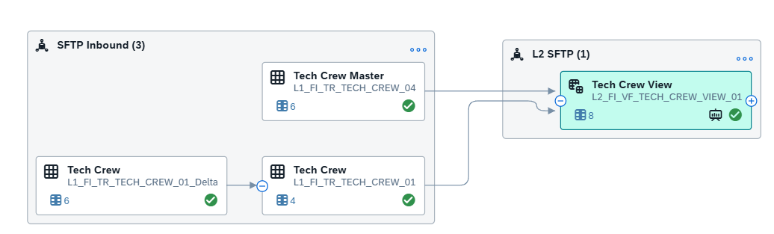

Fact View:
Tech Crew View – L3_FI_VF_TECH_CREW_VIEW_01
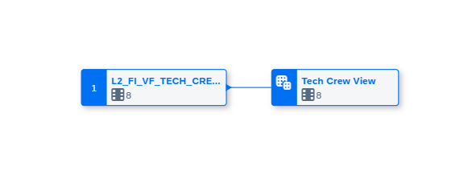
Data Model:

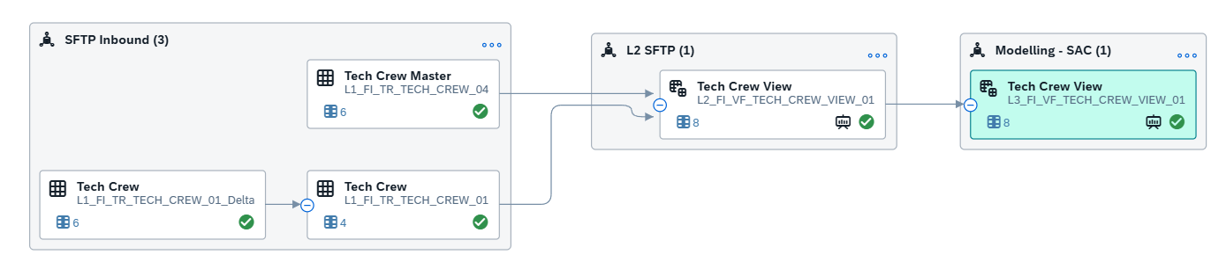

3.2.6 Cabin Crew Transaction Data

Fact View:
Cabin Crew Forecast View: L2_FI_VF_CABIN_CREW_FR_VIEW_01
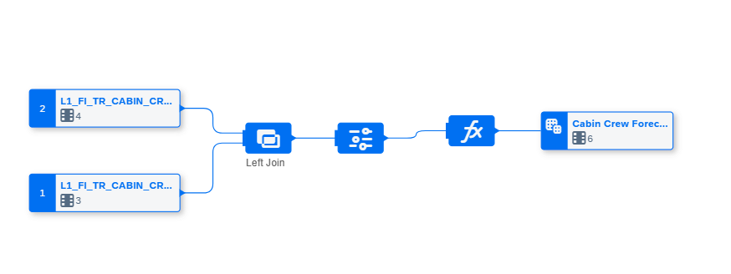

Data Model:

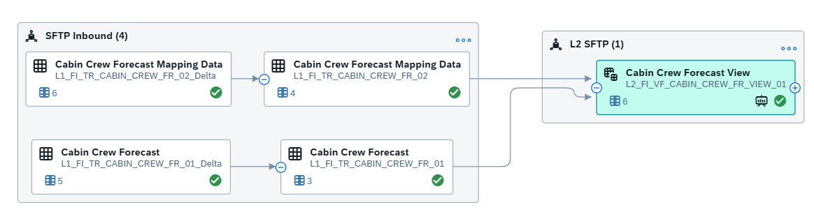

Fact View:
Cabin Crew View - L3_FI_VF_CABIN_CREW_FR_VIEW_01

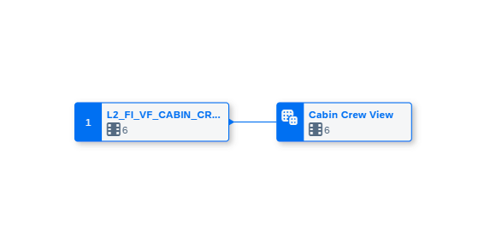
Data Model:
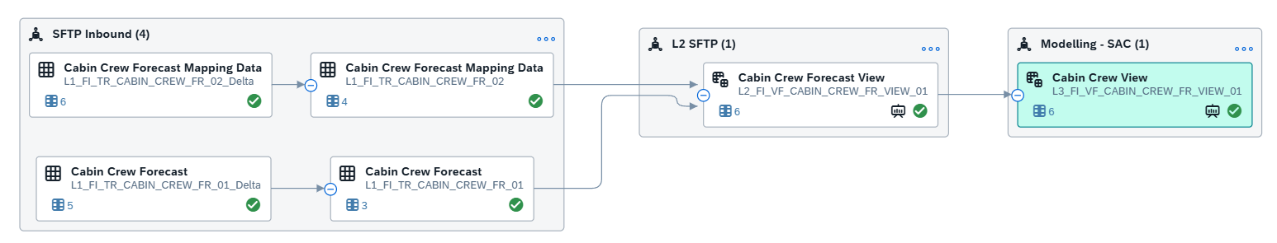

3.3 Technical Details and Mapping
S.No. | View/Table Name | Space & Module Name | Type of Model | Functional Area | Details/Mapping
Division Discerption
1 | Division Description View: L2_FI_GL_SR_DIVISION_DES_VIEW_01 | Modelling-S4hana | SQL Relational Dataset | FI
APVP Data
2 | L1_FI_MP_TR_APVP_01 | L1 SAC Manpower | Local Table | FI
3 | L1_FI_MP_LT_APVP_CONFIG | L1 SAC Manpower | Local Table | FI
4 | L2_FI_MP_VR_APVP_ASSIGNEDPOS | L2 SAC Manpower | View Relational Dataset | FI
5 | L2_FI_MP_VR_APVP_NUMPOS | L2 SAC Manpower | View Relational Dataset | FI
6 | L2_FI_MP_VR_APVP_ADDITIONAL | L2 SAC Manpower | View Relational Dataset | FI
7 | L2_FI_MP_VR_APVP_VACANT | L2 SAC Manpower | View Relational Dataset | FI
8 | L2_FI_MP_VR_APVP_ADDVACCOMB | L2 SAC Manpower | View Relational Dataset | FI
9 | L2_FI_MP_SR_APVP_EXPLODED | L2 SAC Manpower | SQL Relational Dataset | FI
10 | L2_FI_MP_SR_APVP_FINALCOMBVIEW | L2 SAC Manpower | SQL Relational Dataset | FI
11 | L2_FI_MP_SR_APVP_YCOMBVIEW_01 | L2 SAC Manpower | SQL Relational Dataset | FI
12 | L3_FI_MP_VF_APVP_COMBVIEWCONSUMPTION__01 | Modelling SAC | Fact View | FI
APVP Data EC
13 | L1_APVP_DATA | Centralised_IT | Fact View | FI
14 | L1_FI_TR_APVPDATA_EC_CONFIG_01 | SFTP Inbound | Local Table | FI
15 | L2_FI_MP_SR_APVP_EXPLODED_EC_01 | L2 BW/4Hana | SQL Relational Dataset | FI
16 | L2_FI_MP_SR_APVP_MC_EC_02 | L2 BW/4Hana | SQL Relational Dataset | FI
17 | L2_FI_MP_SR_APVP_COMBVIEW_EC_03 | L2 BW/4Hana | SQL Relational Dataset | FI
18 | L3_FI_MP_VF_APVP_COMBVIEW_EC_01 | Modelling SAC | Fact View | FI1
Tech Crew Data
19 | L1_FI_TR_TECH_CREW_01 | SFTP Inbound | Local Table | FI
20 | L1_FI_TR_TECH_CREW_04 | SFTP Inbound | Local Table | FI
21 | L2_FI_VF_TECH_CREW_VIEW_01 | L2 SFTP | Fact View | FI
22 | L3_FI_VF_TECH_CREW_VIEW_01 | Modelling SAC | Fact View | FI
Cabin Crew Data
23 | L1_FI_TR_CABIN_CREW_FR_01 | SFTP Inbound | Local Table | FI
24 | L1_FI_TR_CABIN_CREW_FR_02 | SFTP Inbound | Local Table | FI
25 | L2_FI_VF_CABIN_CREW_FR_VIEW_01 | L2 SFTP | Fact View | FI
26 | L3_FI_VF_CABIN_CREW_FR_VIEW_01 | Modelling SAC | Fact View | FI
Historical Actuals HO and OSS
27 | SAP_FI_IL_I_GLACCOUNTLINEITEMRAWDATA | SAP Partner content | Local Table | FI
28 | L2_FI_GL_VF_ACDOCARAW_01 | Modelling S4ha | Fact View | FI
29 | L2_FI_GL_VF_HISTORICAL_ACTUALS_01 | Modelling S4ha | Fact View | FI
30 | L2_FI_GL_VF_HISTORICAL_ACTUALS_01 | Modelling S4ha | Fact View | FI
31 | L3_FI_GL_VF_HISTORICAL_ACTUALS_01 | Modelling SAC | Fact View | FI

3.4 Currency Translation/Unit Conversion

NA

3.5 Row level security

NA

Data Load Frequency

Task Chain Business & Technical Name | TBD
Space Name
Scheduling Considerations
Run Frequency
Estimated Volume Per Run (IT)
Load Dependencies
Email Notifications
Task Chain Business & Technical Name

Unit Test Results

Scenario # | View | UTR Result | Actual Result (Pass/Fail)
1 | Division Description |  | Pass
2 | Historical Actuals HO OSS |  | Pass
3 | APVP Data |  | Pass
4 | APVP EC Data |  | Pass
5 | Tech Crew Data |  | Pass
6 | Cabin Crew Data |  | Pass

*Note: For all flows UT Document maintain in one file.

Glossary

Term | Definition
LT | Local Table

